What This Project Is
This document explains, in plain language, what actually happens at the school and what our software needs to do about it. No story, no characters — just the situation and the logic behind it.

The basic setup
Every student belongs to one class and one section — this is already fixed at the start of the year, not decided fresh each day. Every teacher is already assigned to certain subjects and certain classes. Every child, if they use the school bus, already has a fixed route and a fixed stop — not chosen daily. So the system already knows, in advance, who teaches what, who's in which class, and who travels on which bus.

What happens in the morning
In the morning, a teacher opens the attendance screen on their phone and marks who's present, class by class, period by period. The moment it's marked, it's saved — a parent can already see it on their own phone within seconds, without asking anyone.
If a child travels by bus, they tap a card when they get on. The system already knows which bus they should be on and which stop they should get off at, so if a child taps the wrong bus, the system notices immediately and tells the office — not hours later when the child doesn't come home on time.
At the school gate, teachers themselves check in using face recognition — no register to sign, no punch card. The camera recognises them and marks their attendance the moment they walk past.

What Happens If the Attendance Machine Isn't Working:
Some mornings, the face-recognition machine might be broken or switched off. When that happens, a teacher can report their own attendance by hand through the app — but this doesn't count immediately. It waits until the Principal or the office confirms it happened. A teacher marking themselves present, with nobody checking, would defeat the whole point of having a machine watch for it in the first place.
The same care applies to money. If a parent pays fees online and the payment succeeds but the screen freezes before showing "success," the system never asks the parent to just trust that it worked — it checks directly with the bank's own confirmation before marking anything as paid. Nothing about money is ever taken on the parent's word alone

How the money side works
Parents pay school fees through the app. The moment a payment is confirmed, a receipt is generated automatically — nobody in the office has to type anything by hand. If a family has more than one child at the school, one single payment can cover fees for both children at once, and each child still gets their own separate receipt.
For the canteen, a child doesn't carry cash. They tap a card, and the amount is deducted from a small wallet balance the parent has already topped up — like a prepaid account, not a bank card. A parent can also set a daily spending limit, or block certain items, directly from their phone.

Why it's built this way
None of this is complicated technology for its own sake. It exists because right now, a school runs on paper attendance registers, cash collection, phone calls to parents, and separate machines that don't talk to each other. This project simply puts all of it in one place, so information moves the moment something actually happens — not hours later, and not only when someone remembers to write it down.

Hostel
Setting up a hostel — deciding how many buildings there are, how many rooms, which bed belongs to which student — only happens once or twice a year, and only the school office does this. But running the hostel day to day — checking who's in at night, letting a student out on a weekend pass, logging visitors, tracking meals — happens every single day, and that's a completely different person's job: the hostel warden.
So the system keeps these two jobs strictly separate. The warden can see which bed a student has, but cannot move them to a different bed or add a new room — that decision stays with the office. This isn't just how the screens are designed; even if someone tried to force it through directly, the system itself would refuse, because the warden was simply never given permission to do that part of the job.

Sports
Buying equipment, registering a coach, and deciding which sports the school offers — that's infrastructure, and it's handled by the school office, the same way hostel rooms are. But running the actual sports program — picking a team, holding practice, recording a match result, letting a coach borrow equipment for the day — is a teacher's job, specifically whichever teacher is assigned to look after sports.
That teacher is picked by the office the same simple way any other responsibility is handed out — no separate account, no separate app, just one more thing added to their existing teacher login.
There's one more detail worth knowing: during PT period, the sports teacher takes attendance for whichever class they're teaching at that moment, exactly the same way a maths or science teacher would for their own subject. It's not treated as something different — PT is just another class period.

Why some actions need a second person to say yes
Not every action in the system happens the moment someone asks for it. A fee refund, a student leaving the hostel for the weekend, a mark being changed after an exam — these all wait for someone senior to approve them first. This isn't slow for the sake of being slow; it exists because money, safety, and academic records are exactly the kind of things that shouldn't depend on just one person's word.
The one rule that never bends anywhere in the system: nobody can approve their own request. A teacher reporting their own attendance because a machine was broken still needs someone else to confirm it actually happened — the person asking and the person confirming can never be the same one.

In an emergency
If something serious happens — a child goes missing on a trip, there's a medical emergency, anything urgent — a staff member can raise an alert directly from their phone. It's built to reach the right people first, not everyone at once. The people closest to the situation are told immediately; parents are told a short time after, once there's something real to tell them, rather than in a first panicked moment before anyone even knows what's actually going on.
Everyone has their own version of the app
A student doesn't get their own separate account. The parent's app itself shows the child's attendance, marks, homework, fees, and bus location. If the school allows older students to see this themselves, they simply use the same parent login on their own phone — not a different account, just the same one.
This isn't a missing feature — it's a deliberate choice, built in from the start. Running two separate logins for every family, one for the parent and one for the child, would mean twice the passwords and twice the things that could go wrong, for information that's really the same family looking at the same child. One shared login does the job just as well, with far less to manage.
And the link itself isn't assumed — it's checked. The system holds a real record of who is whose guardian, and confirms it every single time information is requested, not just once at login. A parent can only ever see their own children — never anyone else's — and that's enforced the same way everywhere in the system, not left to chance.

Roles and Responsibility – User

1. Parent

Sees only their own children's records — attendance, marks, homework, fees, wallet balance, live bus location during an active trip. Never sees anything about another family's child, checked on every single request, not just once at login.

If a child is on the school bus, can see the bus's live position only while the trip is actually running — not a permanent tracking view, and not available once the child has already been dropped or the trip has ended.

Pays fees online; a receipt is generated automatically the moment the bank confirms the payment — nobody in the office types this by hand, and the parent never has to trust a screen alone, since the system checks with the bank directly.

Can top up a canteen wallet, set a daily spending cap, or block specific food items — all from their own phone, without asking the canteen to do it.

If they have more than one child at the school, one single payment can be split across both children's fees, but each child still gets their own separate receipt — this matters for schools that need one receipt per child for their own records.

If the school allows it, an older student uses this exact same login on their own phone — there is no separate student account anywhere in the system.

Can raise a complaint or message a teacher through the app, but this is logged, not a private unmonitored chat — the school can always see what was said.

2. Faculty (Teacher)

Marks attendance for whichever class and period is currently on their timetable — nothing more, nothing less than their own assigned periods.

Puts up homework and learning material, and enters exam marks only for the subjects and sections they're actually assigned to teach — not for the whole school.

Checks in for their own daily attendance through face recognition at the school gate — this happens automatically the moment they walk past, no register to sign.

If the face-recognition camera is broken that day, can report their own attendance manually through the app — but this is only ever marked "pending," never confirmed automatically. Someone senior — the Principal or the office — has to confirm it actually happened before it counts.

A teacher can never be the one to confirm their own attendance; that would defeat the entire reason a machine is used to watch for it.

Has no access to a web version of the system at all — every part of a teacher's job, including any extra duties described below, works from the phone only. This was a deliberate choice so teachers never need a computer just to do their job.

3. Class Advisor (faculty login)

Given to one teacher per section by the office — not a separate account, just an added responsibility on their existing login.

Unlike an ordinary subject teacher, sees the FULL picture for their section — attendance and marks across every subject, not only their own — because this person is meant to be the one adult tracking the whole child, not just one subject.

Can approve a student's short leave request for that section, and write remarks on report cards.

Cannot see or act on any other section they are not the advisor for — this responsibility is tied to one specific section, not the whole school.

4. Academic Coordinator (faculty login)

Builds the timetable, sets up exams, opens and closes the marks-entry window, and checks marks before report cards are generated — all done through the phone, step by step, rather than a big spreadsheet-style screen, because there is no computer version of this role either.

Assigning a substitute teacher when someone is absent is the single most time-sensitive part of this job — it needs to happen in a hallway at 8am, not from a desk later in the day, which is exactly why this stays on the phone rather than being pushed to a website.

Reviews marks a teacher has entered and can either approve them or send them back with a comment — but cannot silently overwrite what a teacher entered; any change is recorded as a correction, not a quiet edit..

5. Sports In-Charge (faculty login)

Runs the actual day-to-day sports program: holds trials, builds teams, schedules practice, records who attended, enters match results, and tracks a student's sporting achievements over time.

Can issue equipment to a student or team and record its return — but cannot add a brand-new type of equipment to the school's inventory; that's the office's job, since it's a purchasing decision, not a daily one.

Can assign an already-approved coach to a team, but cannot register a brand-new coach — registering a coach means checking their police verification, and that stays with the office as a compliance matter, not a day-to-day sports decision.

During PT period, takes attendance for whichever class is scheduled at that time, exactly the same way any other subject teacher does for their own subject — PT is treated as an ordinary class period, not a special case needing its own separate system.

6. Hostel Warden

Handles everything that happens inside the hostel on a daily basis — night roll call, checking students in and out on a weekend pass, logging visitors, tracking who attended meals.

Can see which student is assigned to which room and bed, but cannot create a new room, add a new bed, or move a student to a different one — that decision is made once or twice a year by the office, not something a warden changes day to day.

In a genuine emergency, can let a student leave immediately without waiting for approval first — but this instantly creates a review request for the Principal, and the exit record cannot be closed until that review happens. This way, urgency is never an excuse for zero accountability afterward.

7. Bus Attendant

Scans a student's card as they board or leave the bus — sees only that child's name, photo, and their assigned stop, nothing more about them.

If a child taps onto the wrong bus, the system flags it the moment it happens and alerts the office immediately — not left to be discovered only when the child fails to arrive home.

Has no access to route planning, driver assignment, or any setup — this role exists purely for the one physical task of watching who gets on and off.

8. Canteen Staff

Scans a card at the counter, and the amount is taken from the child's prepaid wallet -- no cash is ever handled at this counter.

If a purchase would break a limit the parent has set — daily spending cap, or a blocked item — the sale is stopped at the counter itself, not discovered afterward.

Sees a child's name, photo, class, and whether their wallet has enough balance - never the actual balance amount itself, and nothing else about the child.

9. Finance / Accounts

Sets up fee structures, records payments, processes refunds, and runs staff payroll.

Every online payment is confirmed directly with the bank's own record before it's marked paid — a parent's screen showing "success" is never treated as proof on its own.

Can request a refund, but cannot approve their own request above a certain amount — that needs the Principal's sign-off, so no single person in Finance can move money out of the school unchecked.

10. Vice Principal

Handles a defined portion of day-to-day academic oversight and can approve a limited set of requests on the Principal's behalf.

Every single thing the Vice Principal is able to do, the Principal can also do — this relationship is fixed, so a permission given to the Vice Principal never accidentally goes further than the Principal already has.

11. Principal

Has everything the Vice Principal has, plus a further set of things only the Principal can do — final sign-off on report cards before they're sent to parents, higher-value approvals, and sounding a school-wide emergency alert.

Has both a website, for full reports and bulk actions like signing off forty report cards at once, and a phone app for approvals, announcements, and emergencies when away from a desk — the same features work identically on either.

Reviews the office's financial and administrative actions for oversight — this is read-only; the Principal observes here, but doesn't make changes from this screen.

12. Admin (School Office)

Handles the school's heavier, less frequent setup work — student records, admissions, transport routes and vehicles, hostel room structure, sports equipment and facilities, staff accounts.

Is the only role that works purely from a website rather than a phone, because this kind of setup work — tables, records, bulk actions — suits a bigger screen far better than a phone ever could.

Assigns every extra teacher responsibility — Class Advisor, Academic Coordinator, Sports In-Charge, Health In-Charge — the same simple way each time, so there's one consistent process for handing out responsibility, not a different one for each type.

Features and functions – login wise

Super Admin(if needed)

Would create and manage Admin accounts, if this school ever needed more than one — not required here, since the school runs as a single unit, not a chain of schools.

Full system configuration access — the kind of setting that affects the whole system at once, not tied to any one feature.

System-level settings like how long old records are kept before they're purged, and other foundational rules that shouldn't be changed casually.

This role exists in the system's design in case it's ever needed later, but nobody currently holds it — there's simply no one to manage above the school's own Admin at this scale.

Admin

Creates and manages every student, staff, and guardian record in the school — this is the starting point every other feature in the system depends on, since nothing else can happen until a student or teacher exists in the system.

Creates Faculty accounts and switches on extra duties for them — Class Advisor, Academic Coordinator, Sports In-Charge, Health In-Charge — the same simple process every time, regardless of which duty is being assigned.

Sets up transport from scratch — which vehicles the school owns, which routes exist, which stops are on each route, and which student is allocated to which bus. Once this is set up, the Bus Attendant and the parent's live tracking both depend on it being correct.

Sets up the hostel's physical structure — how many blocks, how many rooms, how many beds, and which student is assigned to which bed. This is done once or twice a year, not daily, which is exactly why it's kept separate from the Warden's day-to-day job.

Sets up sports infrastructure — buying and tracking equipment, registering facilities, and registering a coach along with checking their police verification. This is compliance and purchasing work, not something that happens during a practice session, which is why it sits with Admin rather than the Sports teacher.

Manages the fee structure for the whole school, and reviews any refund or concession Finance wants to give above a certain amount — a second check before money leaves the school.

Registers every physical device the system relies on — the face-recognition terminal at the gate, the tablet on the bus, the tablet at the canteen counter. Each device gets its own permanent credential, separate from any person's login.

Can view the school-wide audit log — a record of who did what and when, across every role — so that if something needs to be traced back later, there's always a clear trail.

Every one of these tasks happens only through the website — Admin has no mobile app at all, because this kind of setup work suits a full-sized screen far better than a phone.

Principal

Holds everything Vice Principal holds, plus a further set of powers that belong only to this role — this relationship is fixed by design, so nothing the Vice Principal can do ever goes beyond what the Principal can already do.

Gives the final sign-off on report cards before they go out to parents — the last check in the chain, after a teacher has entered marks and the Academic Coordinator has verified them.

Approves the school's higher-value requests — large refunds, large concessions, extended leave — anything significant enough that one person alone shouldn't decide it.

Is the only role that can sound a school-wide emergency alert, and even this requires the Principal to re-confirm their identity first, so a stolen or unattended phone can't accidentally trigger it.

Has a live map of every bus currently on the road, and a single search bar to quickly look up any student or staff member — both built for moments when the Principal is standing in a hallway, not sitting at a desk.

Can review the school office's financial and administrative actions — but only to observe, never to edit; this is oversight, not a second way to make changes.

Has both a full website, for detailed reports and reviewing many report cards at once, and a phone app that does everything else — approvals, announcements, emergencies — with both versions doing the identical job, not a stripped-down mobile copy.

Vice Principal

Handles a defined slice of the school's day-to-day academic oversight — reviewing attendance trends and performance across sections, without needing to involve the Principal for every routine check.

Can approve a limited set of requests on the Principal's behalf, reducing how much has to wait specifically for the Principal's attention.

Every single thing this role can do is also something the Principal can do — this isn't two independent sets of permissions maintained separately, it's one list that the Principal's list is built directly on top of, so nothing the Vice Principal is given can ever silently go further than what the Principal already has.

Finance / Accounts

Sets up how fees are structured for the school, and records every payment that comes in, whether it arrives online or as cash handed in at the office.

Can process a refund or a concession for a family — but above a certain amount, this needs the Principal's approval first, and Finance can never approve their own request regardless of size, so no single person in this role can move money out of the school unchecked.

Runs staff payroll, calculating what's owed based on attendance and any extra hours recorded.

Every online payment is checked directly against the bank's own confirmation before it's marked as paid — a parent's screen simply showing "success" is never treated as proof by itself.

Like Admin, this role works only through the website — the nature of the work (structured financial records, bulk reconciliation) fits a bigger screen.

Faculty

Marks attendance only for the classes and periods actually on their own timetable — never for a class they don't teach.

Enters homework, learning material, and exam marks, but only for the subjects and sections they're assigned to — the system checks this every time, not just once.

Gets checked in automatically for their own attendance through face recognition at the gate each morning — no manual sign-in needed on a normal day.

If the recognition camera is down that day, can report their own attendance by typing it in — but this is only ever marked "pending" until Admin or the Principal confirms it actually happened. A teacher is never allowed to be the one who confirms their own attendance.

Every part of this role, including any extra duties layered on top, works from the phone only — there is deliberately no website version, so a teacher never needs a computer just to do their job.

Faculty + Class Advisor (faculty login)

Unlike an ordinary subject teacher, sees the complete picture for one assigned section — attendance and marks across every subject that section takes, not just their own — because this person is meant to be the one adult keeping track of the whole child.

Can approve a short leave request for a student in that section directly, without it needing to go further up.

Writes remarks on report cards for students in their section, adding the personal observation a report card alone wouldn't capture.

Faculty + Academic Coordinator (extra duty, same login)

Builds the school's timetable, sets up exams, and controls when the marks-entry window is open or closed — all of this done step by step on the phone, since there's no desktop version even for this heavier work.

Assigns a substitute teacher the moment someone is absent — deliberately built to happen quickly from a hallway at 8am, not later from behind a desk, since that's exactly when this decision is actually needed.

Reviews marks teachers have entered, and can approve them or send them back with a comment — but can never silently change what a teacher entered; any change is recorded as a correction, never a quiet edit.

Faculty + Sports In-Charge (extra duty, same login)

Runs the entire day-to-day sports program — holding trials, forming teams, scheduling practice, recording who attended, and entering match results as they happen.

Can issue equipment to a student or team and record when it's returned — but cannot add a brand-new type of equipment to the school's inventory, since that's a purchasing decision that belongs to Admin.

Can assign an already-registered coach to a specific team, but cannot register a new coach themselves — registering a coach means verifying their police clearance, which stays a compliance matter for Admin.

During PT period, takes attendance for whichever class is scheduled, using the exact same attendance screens any subject teacher already uses — PT was deliberately never given its own separate system, since it's just another class period.

Parent

Sees only their own children's information — attendance, marks, homework, fees, wallet balance, and live bus location while a trip is actually in progress — never anything about another family's child.

Pays fees directly through the app; a receipt is generated automatically the moment the bank confirms payment, with no need for the office to type anything by hand.

Tops up the canteen wallet and can set a daily spending limit or block specific items — enforced at the canteen counter itself, not just a setting that's ignored later.

If the school allows it, this same login is used by the student themselves on their own phone — there is no separate student account anywhere in the system.

Hostel Warden

Handles everything that happens inside the hostel daily — night roll call, letting students out on a weekend pass, logging visitors, and tracking who attended each meal.

Can see which student is assigned to which room and bed, but cannot create a new room or move a student to a different bed — that decision is made by Admin, not changed day to day.

In a genuine emergency, can let a student leave immediately without waiting for approval — but this instantly creates a review request for the Principal, and the record can't be closed until that review happens, so urgency never becomes an excuse for no accountability.

Bus Attendant (device login — the terminal itself is registered, not the person)

Scans a student's card as they board or get off, seeing only that child's name, photo, and their assigned stop — nothing more.

If a child boards the wrong bus, this is flagged the moment it happens and the office is alerted immediately, not discovered hours later when a child doesn't arrive home.

Because the login belongs to the device, a different staff member covering the shift needs no separate account — the system trusts the terminal, not who happens to be holding it that day.

Canteen Staff (device login — same device-based approach as the bus)

Scans a card at the counter, and the amount is deducted directly from the student's prepaid wallet — no cash is ever handled here.

Sees the student's name, photo, class, and whether their wallet has enough balance — never the actual balance figure itself, and nothing else about the child.

If a purchase would break a limit the parent has set, the sale is stopped right at the counter, not discovered as a problem afterward.

Tabs and features

Super Admin (reserved, not active for now)
Would see everything below, plus these exclusive tabs, if ever activated:
- Cross-school Dashboard — only relevant if the school ever becomes part of a group of schools
- Admin Account Management — create and manage Admin accounts
- System Settings — retention rules, global configuration
- (plus every tab listed under Admin, Principal, Vice Principal, Faculty, Finance, Hostel Warden below — full visibility, no restrictions)

Admin

Dashboard — school-wide summary: attendance, fees, open items

Students — create and manage student and guardian records

Staff — create Faculty accounts, assign extra duties (Class Advisor, Academic Coordinator, Sports In-Charge, Health In-Charge)

Admissions — enquiry pipeline, application review, enrolment

Transport — vehicles, routes, stops, student bus allocation

Hostel Setup — blocks, rooms, beds, bed allocation

Sports Setup — equipment inventory, facilities, coach registration and verification

Finance Oversight — fee structures, reviewing refund/concession requests above a set value

Devices — register biometric terminals, bus terminals, canteen terminals

Certificates — transfer certificates, bonafide, conduct certificates

Audit Log — school-wide activity trail

Policy Documents — upload and version SOPs

Principal

Dashboard — leadership summary, full drill-down tables (web) or lighter tiles (mobile)

Approvals — refunds, concessions, leave, staff attendance manual entries, all in one inbox

Academic Oversight — class/section-wise attendance and performance, teacher performance

Report Card Sign-off — final review before report cards reach parents

Audit Review — read-only view of Admin's actions

Announcements — compose and publish, whole school or targeted

Emergency / SOS — school-wide alert, re-authentication required before it fires

Live Bus Map — every active trip, current position

Lookup — quick search for any student or staff member

Policy Documents — create, version, publish

(plus every tab listed under Vice Principal below — full access, not a separate set)

Vice Principal

Dashboard — academic oversight summary

Approvals — a limited set, as delegated by the Principal

Academic Oversight — read access to attendance and performance trends

Finance / Accounts

Dashboard — fee collection status, outstanding obligations

Fee Structures — set up and edit

Payments — record, view, reconcile

Refunds & Concessions — process; above a set value, requires Principal approval

Payroll — calculate and process staff salary

Wallet Reconciliation — canteen and transport wallet ledger review

Faculty

My Timetable — today's classes and periods

Attendance — mark for own assigned classes

Homework / LMS — post material, assignments

Marks Entry — enter exam marks for own subjects

My Attendance — own record; self-report if biometric terminal is down (stays pending until confirmed)

Leave Request — apply, check balance and status

Communication — notices, class communities, messaging (logged, not private)

Extra tabs, only visible if the duty is assigned:

Class Advisor — Section Dashboard, full all-subject marks for the section, leave approval, report card remarks

Academic Coordinator — Timetable Builder, Substitute Assignment, Exam Setup, Marks Verification, Report Card Generation, Syllabus Coverage, Board Exam Roll

Sports In-Charge — Trials, Teams & Rosters, Training Attendance, Fixtures & Results, Equipment Issue/Return, Student Sport Profile, PT Period Attendance

Health In-Charge — Medication Rounds, Infirmary Visits, Sick Bay, Camp Health Checkups

Parent

Dashboard — per-child summary, switch between children if more than one

Attendance — own child's record

Marks & Report Cards — own child's academic record

Fees — pay, view receipts, request extension

Wallet — top up, set spending limit, block items

Bus Tracking — live location, only while a trip is active

Homework — own child's assignments

Communication — notices, message a teacher (logged)

Complaints — file and track

Hostel Warden

Roll Call — night attendance

Gate Passes — issue and approve outings, emergency exit

Visitor Log — entries and exits

Mess Attendance — daily meal tracking

Room View — read-only, cannot create rooms or reassign beds

Bus Attendant (device login)

Boarding Scan — tap to mark a child on or off

Today's Route — assigned stops for the current trip

Canteen Staff (device login)

Sale — scan card, deduct from wallet

Balance Check — sufficiency only, not the actual amount

full component breakdown

1. Dashboard

Date/range selector (today, this week, this month, custom range)

School selector — not shown for this deployment (single school only); would only appear if Super Admin is ever activated for a multi-school setup

Summary cards — vary by who's looking:

Admin: total attendance today, fee collection today, pending admissions, open device alerts

Principal / Vice Principal: attendance % across sections, pending approvals count, open complaints, syllabus coverage at a glance

Finance: fee collection today, outstanding obligations, refunds pending sign-off

Parent: today's attendance for each child, wallet balance, next fee due date

Faculty: today's timetable, pending marks-entry windows, own attendance status for the day

Alerts panel — varies by role:

Admin: device offline (biometric terminal, bus terminal), pending staff attendance manual entries awaiting confirmation, low canteen wallet balances flagged

Principal: open SOS/emergency incidents, approvals nearing their deadline, wrong-bus boarding alerts

Hostel Warden: pending gate pass requests, unusual mess attendance drop

Quick-access shortcuts to pending-action tabs (e.g., "5 approvals waiting" → jumps straight to the Approvals tab; "3 manual attendance entries pending" → jumps to Staff Attendance)

Tapping any summary card or alert opens the relevant detail screen directly — never just a static number with nowhere to go

2. Attendance

Class/section selector (Faculty, Class Advisor) or school-wide filter (Admin, Principal)

Present/Absent/Late toggle per student, one tap per row

Auto-marked banner for biometric-based staff attendance — shows "Marked automatically" so it's clear no manual action was taken

Pending-confirmation banner for any manual self-reported entry, with a clear "waiting for approval" state, never shown as a plain success tick

Offline indicator — shows when attendance was taken without signal and is queued to sync, with a per-record outcome once it does (Accepted / Already Recorded / Rejected)

Correction request button — opens a reason field, creates a traceable correction rather than silently overwriting the original entry

3. Approvals

Single inbox, every request type mixed together (fee concession, refund, hostel outing, staff manual attendance, mark correction)

Sort by urgency — closest to its deadline shown first

Filter by type, if the list is long

Tap an item → shows the request detail, the reason given, and who raised it

Approve / Reject buttons, with an optional comment field

Approved/Rejected history — a record of past decisions, so nothing disappears once actioned

4. Fees & Payments

Fee structure view — what's owed, broken down by term/category

Payment history — every payment made, with receipt access per payment

Pay Now button (Parent) — opens the payment flow; success only ever confirmed after the bank's own confirmation, never from the screen alone

Refund/Concession request form (Finance) — reason field mandatory, routes to approval if above the set value

Multi-child payment — one payment screen can cover more than one child at once, generating a separate receipt per child automatically

5. Wallet & Canteen

Balance view — sufficiency shown to canteen staff, actual amount shown only to Parent and Finance

Top-up button (Parent) — add funds, set up auto-top-up

Spending limit / item block settings (Parent) — daily cap, restricted item list

Transaction history — every canteen sale, timestamped

Sale screen (Canteen device) — scan, confirm, done; blocked-sale reason shown immediately at the counter if a limit is hit

6. Transport

Live map (Admin, Principal) — every active trip, refreshed every 15 seconds, tap a vehicle for route and boarding status

Route/stop setup (Admin only) — create and edit

Student allocation (Admin only) — assign a student to a route and stop

Boarding scan screen (Bus Attendant device) — name, photo, stop only; wrong-bus flag fires immediately if triggered

My child's bus (Parent) — live position only while a trip is active, nothing shown once it ends

7. Hostel

Structure view (Admin) — blocks, rooms, beds, editable; read-only for Warden

Bed allocation screen (Admin) — assign/reassign a student to a specific bed

Night roll call (Warden) — roster with photos, one tap per student, present/absent

Gate pass screen (Warden) — outing type, reason, expected return time; Approve/Reject button if it needs sign-off, or instant-issue for emergencies

Visitor log (Warden) — name, relation to student, entry/exit time

Mess attendance (Warden) — meal-by-meal roster

Emergency exit button (Warden) — issues immediately, but auto-creates a pending review for Principal, shown clearly as "awaiting review," not closed silently

8. Sports

Equipment & facility master data (Admin) — add/edit inventory, define spaces

Coach registration (Admin) — identity, police verification with expiry tracking

Trials screen (Sports In-Charge) — record results per student

Team & roster builder (Sports In-Charge) — add/remove students, assign a pre-registered coach

Training attendance (Sports In-Charge) — same present/absent pattern as class attendance

Fixture & result entry (Sports In-Charge) — score, winner, timestamp locked to after the scheduled start

Equipment issue/return (Sports In-Charge) — scan/select item, mark out or back

Student sport profile (composed view) — roster history, achievements, trial results, all in one screen

9. Homework / LMS / Syllabus

Homework list (Faculty, post; Parent/Student, view) — title, due date, attachment

Submission review (Faculty) — per-student list, mark reviewed

Syllabus tracker — chapter-by-chapter completion, percentage bar, colour-coded (on track / slipping / behind)

Coordinator's coverage view — read-only summary across all subjects/sections, doesn't duplicate what each teacher already marks

10. Assessment / Exams / Report Cards

Exam setup (Academic Coordinator) — name, dates, subject-by-subject schedule

Marks entry (Faculty) — per student, own subject only

Marks verification (Academic Coordinator) — anomalies flagged automatically (way outside class average), approve or return with a comment

Report card generation — async job, push notification when ready, not a live wait screen

Report card sign-off (Principal) — bulk review before publishing to parents

Report card view (Parent) — read-only, per child

11. Communication

Announcements — audience picker (whole school / class / individual), publish

Messaging — parent-teacher, always logged, never a private unmonitored channel

Notification preferences — which channel (SMS/push/email) per notification type

Complaints — file, track status, resolution notes

12. Incidents, Discipline & Safety

Incident report form — severity, category, description; severity decides escalation automatically

Discipline case tracker — findings, actions taken, restricted to leadership

SOS button — always reachable, requires re-authentication before firing, shows "Help alerted" immediately after

Escalation status — who's been notified so far, without exposing internal escalation timing to the person who raised it

13. Documents & Certificates

Policy document upload (Principal) — version history, acknowledgement tracking per staff member

Certificate generation (Admin) — transfer certificate, bonafide, conduct — templated, not typed fresh each time

Document library — scoped by who's allowed to see which category

14. Camps

Camp setup (Admin) — dates, partner organisation, participant list

Checkup recording (Health staff) — same visit pattern as infirmary, tagged to the camp

Follow-up tracker — flags any finding needing further action after the camp ends

15. Devices

Device registration (Admin) — biometric terminal, bus terminal, canteen terminal, GPS tracker

Device status list — online/offline, last-seen timestamp

Blocklist sync status — for offline-capable terminals

16. Audit & Reports

Audit log viewer (Admin, Principal) — filterable by actor, action, date, read-only

Reports & Analytics — academic oversight, finance dashboard, hostel dashboard; each pulling from the same dashboard component shape covered earlier, just a fuller drill-down version

Bulk operation status — job progress, row-level error detail if something in a bulk import failed

Shared Designs — same shape, different content

1. Dashboard — used by 7 logins
One layout: date/range selector, summary cards, alerts panel, quick-access shortcuts that jump to the relevant tab.

Admin — device status, admissions, collection today

Principal (web + mobile) — approvals pending, academic oversight, open SOS

Vice Principal — delegated approvals, oversight subset

Finance — collection, outstanding fees, refunds pending

Faculty — today's timetable, pending marks windows, own attendance status

Parent — per-child summary, wallet balance, next fee due

Hostel Warden — pending gate passes, mess attendance anomaly
Same component, different data source per login — this is the clearest and most heavily reused design in the whole system.

2. Roster + Present/Absent/Late tap — used by 4 logins
One row per person, one tap to mark status.

Faculty — marking a class's daily/period attendance

Sports In-Charge — training session attendance (same shape, roster is a team, not a class)

Hostel Warden — night roll call (roster is a hostel wing, not a class)

Admin/Principal — staff biometric fallback confirmation (roster is "today's manual entries," not students)
Genuinely the same component reused four times — build once as a generic "roster + status toggle" widget.

3. Approvals inbox — used by 3 logins
One list, sorted by urgency, tap for detail, Approve/Reject with optional comment.

Principal — full inbox, every request type

Vice Principal — a delegated subset, same UI

Admin — reviews specific request types routed to them
Same engine, same screen — the request type changes, the screen never does.

4. Searchable person lookup + summary card — used by 4 places
Single search bar, tap a result, see a read-only summary card.

Principal — Lookup (any student or staff)

Admin — staff/student directory

Academic Coordinator — picking a substitute teacher (same list, filtered to "free this period")

Class Advisnor — viewing their section's roster
Same list-and-card shape; only the underlying query (all staff vs available staff vs one section) differs.

5. Marks table — used by 3 logins, 3 different modes of the same table

Faculty — entry mode (editable fields)

Academic Coordinator — verification mode (read + flag anomaly + approve/return)

Parent — view-only mode
Same columns, same row shape (student, subject, score) — only whether a cell is editable changes.

6. Live map — used by 2 logins

Principal — every active bus, all routes

Parent — only their own child's bus, only while a trip is active
Same map component, same marker style — scope of what's queried is the only difference.

7. Card-tap scan screen — used by 2 device logins
Tap card → show name/photo → confirm action.

Bus Attendant — confirms boarding/alighting

Canteen Vendor — confirms a sale
Visually almost identical despite completely different business logic underneath — same "device screen" shape.

8. Wallet/balance card — used by 2 logins, deliberately different visibility

Parent — full balance, top-up button, spending limits

Canteen Vendor — sufficiency only ("balance OK" / "insufficient"), never the actual number
Same card shape, but this one's a case where the design is shared while the data itself is deliberately restricted, not just relabeled — worth remembering that "same design" doesn't always mean "same visibility rules."

Standalone designs — count 1, built once, used nowhere else

Timetable builder (Academic Coordinator) — the sequential period-by-period edit flow is genuinely unique; nothing else in the system edits a schedule this way

Report card generation + sign-off (Academic Coordinator → Principal) — the async-job-with-push-notification pattern doesn't repeat elsewhere

Emergency SOS button (Principal) — the re-authentication-before-firing pattern is specific to this one action

Hostel gate pass form (Hostel Warden) — outing/emergency exit fields are specific to this workflow

Fixture/result entry (Sports In-Charge) — score entry tied to a scheduled match time is its own shape

Payment/checkout flow (Parent, Finance) — genuinely two different flows even though both touch money: Parent pays, Finance reconciles — not the same screen

Colors and Design Typography

Color Palette

Primary — Register Ink Blue #1E3A5F
A deep blue-black, drawn from the fountain-pen ink used to fill attendance registers, mark sheets and report cards by hand for generations — the one colour that has meant "this is now the official record" in an Indian school long before any app existed. Use for primary buttons (Submit, Approve, Publish, Pay), active tab indicators, and key links. Serious without being cold.

Secondary — Report Card Green #4A7856
A muted, slightly dusty sage (like the faded green used on old report-card grade bands, not a bright "success" green) for secondary actions — Edit, Filter, Export — and to visually separate the "record-keeping" side of the app (attendance, marks, homework) from the "money/approval" side (fees, refunds, concessions).

Neutrals (for backgrounds, cards, borders, text)

Background: #F6F5F1 — soft unbleached-paper tone, easy on the eyes for a parent scrolling a long attendance or fee history

Surface/card: #FFFFFF

Border/divider: #E3E1D8

Body text: #22201C (warm near-black, not pure black — easier to read on a phone screen in direct sunlight, which matters for a parent checking the bus tracker outdoors)

Muted/secondary text: #78756B

Status colors (critical here — you have Pending/Approved/Rejected states throughout Attendance, Fees, Approvals, Boarding, Hostel and Wallet)

Success/Approved: #2F7D4F (muted green, distinct from Secondary above) — used for Present, Paid, Approved, Boarded, Resolved

Warning/Pending: #B8863B (amber-gold, echoes the ink tone) — used for Pending, Due, Awaiting Pickup, Under Review

Error/Rejected: #B33A2E (a red-leaning rust, close enough to Primary to feel related, far enough to read as "alert" clearly) — used for Rejected, Absent, Overdue, Not Boarded, Wrong Bus

This whole palette is genuinely the visual range of a school's own paper trail — ink, aged paper, grade-band green — so it's grounded in the actual subject rather than an arbitrary UI kit.

Typography

Primary/UI font — Plus Jakarta Sans
Used for all interface chrome: headers, tile labels, buttons, form fields, list titles, table headers and body copy. Its wide apertures hold up at the small bottom-navigation labels and meta captions that appear on every card, and its 800 weight gives headings presence without needing a second display face.

Numeric/data font — IBM Plex Mono
Used wherever figures must align in a column or be compared down a list: marks tables, attendance percentages, fee amounts, wallet balances, exam timetables, and bus stop arrival times. Tabular figures matter most in Assessment, Finance and Wallet, where a misaligned digit is genuinely hard to catch on a phone screen.

Headings and section titles — Plus Jakarta Sans 800
Same family, heavier weight, never a separate decorative face. For a records tool used daily by parents, faculty and wardens alike, one family with a clear weight hierarchy keeps every tab feeling consistent whether it's Attendance, Fees or Bus Tracking.

School EOS — Database Schema

Key notation used throughout: PK = Primary Key · FK = Foreign Key (table.column shown in brackets) · UK = Unique Key · CK = Composite Key · AK = Alternate/Candidate Key

Engine assumption: Supabase PostgreSQL (ACID-compliant). Notes on ACID enforcement are at the end of each module and summarized at the bottom.

MODULE 1 — Organization Master Data

school

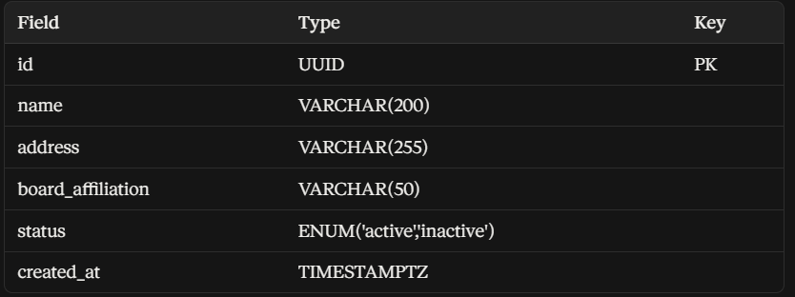

academic_year

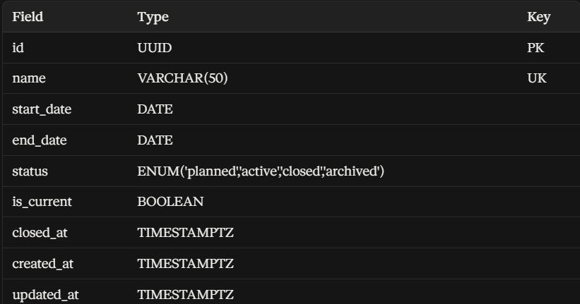

Grade

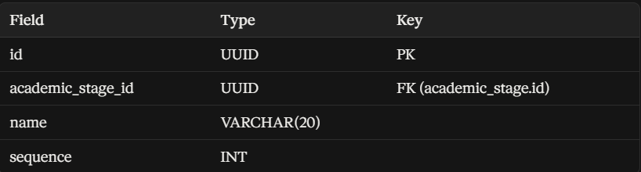

Section

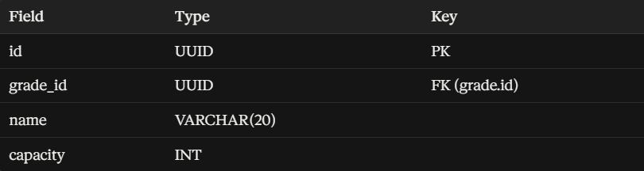

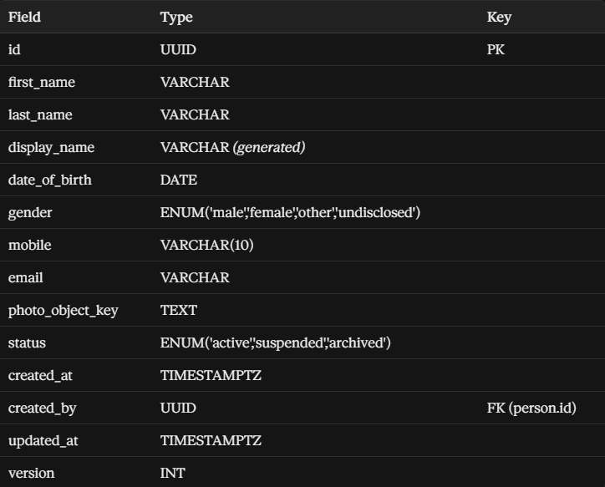

staff (one role a person can hold on top of the person record)

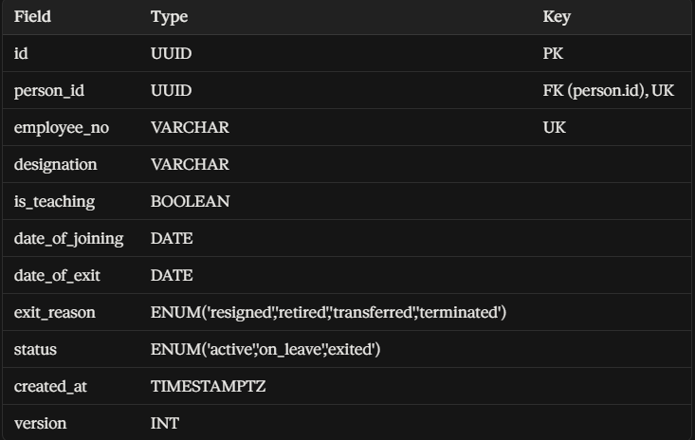

student (the other role a person can hold on top of the person record)

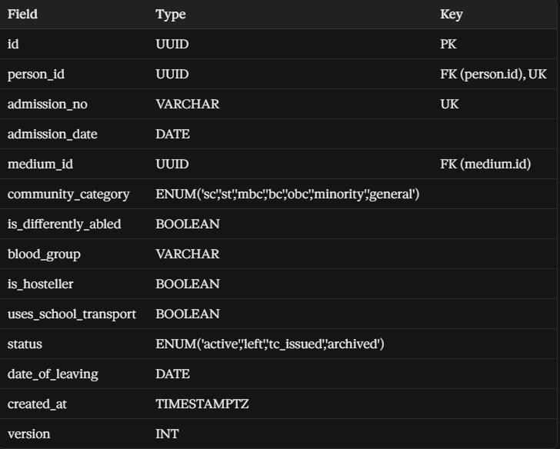

MODULE 3 — Academics & Attendance

timetable_slot

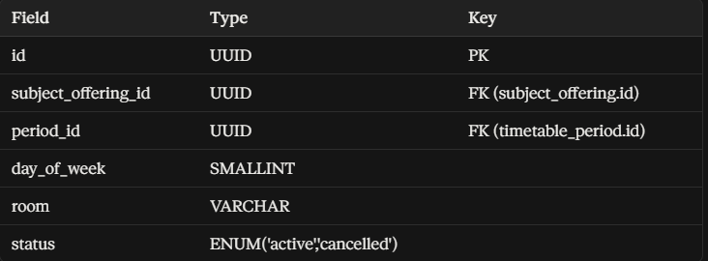

attendance_session

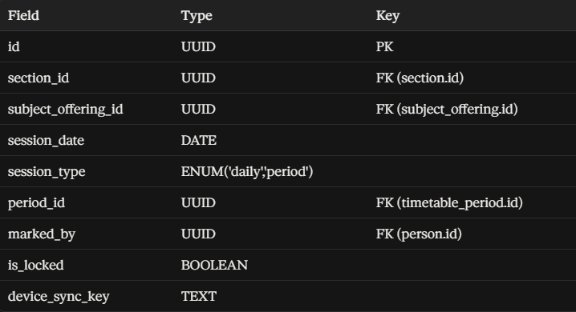

staff_attendance_event (face-recognition and manual fallback — covered in detail earlier)

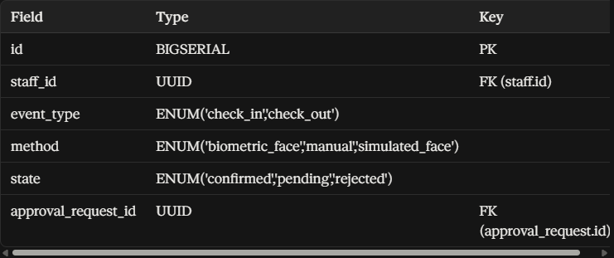

MODULE 4 — Assessment & Report Cards

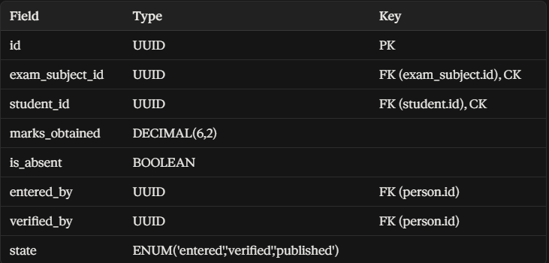

MODULE 5 — Approvals (the shared engine every other module routes into)

approval_request

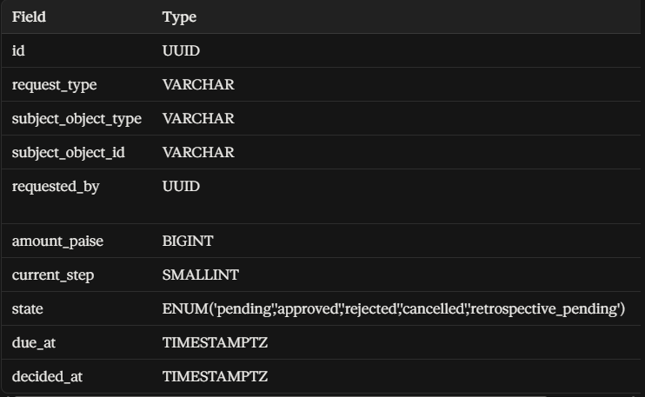

MODULE 6 — Finance

fee_demand

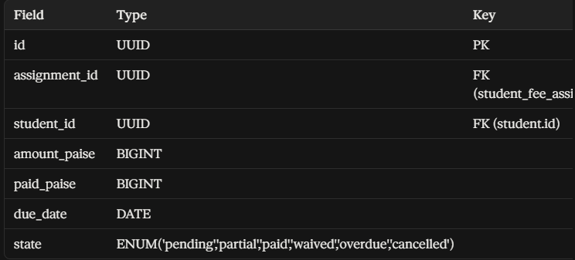

Payment

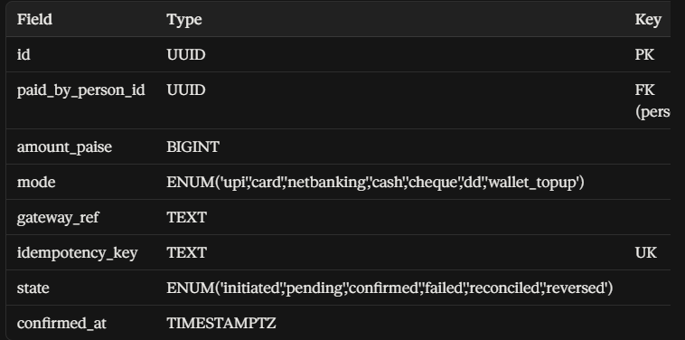

MODULE 7 — Wallet & Canteen

wallet_ledger_entry (the authoritative money record — every other wallet table refers back to this one)

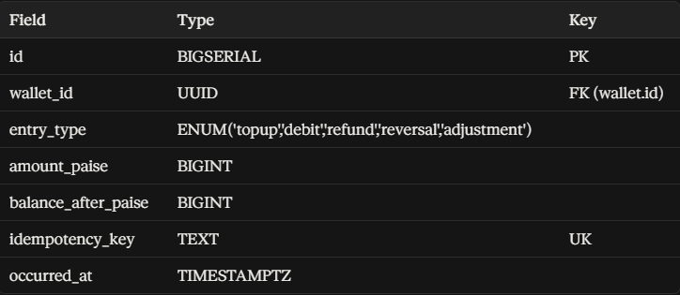

pos_transaction

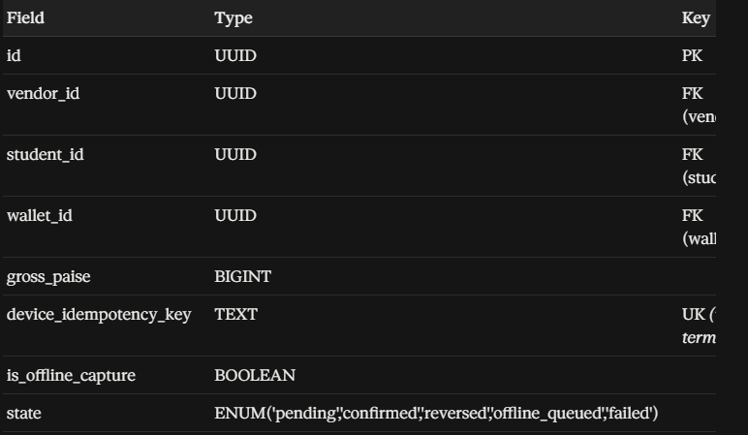

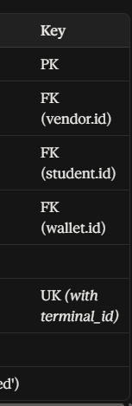

MODULE 8 — Sports

fixture_result

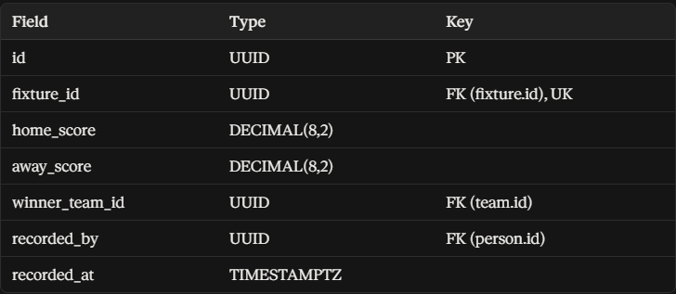

MODULE 9 — Hostel

hostel_allocation (Admin-only write — this is the structure/allocation boundary covered earlier)

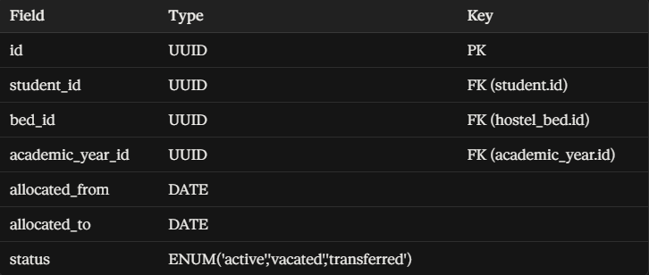

gate_pass

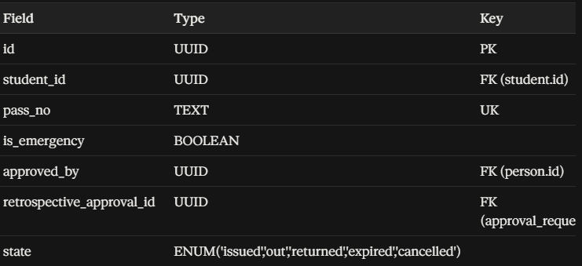

MODULE 10 — Transport & Cards

card_tap_event (the one shared table both bus boarding and canteen sales route through)

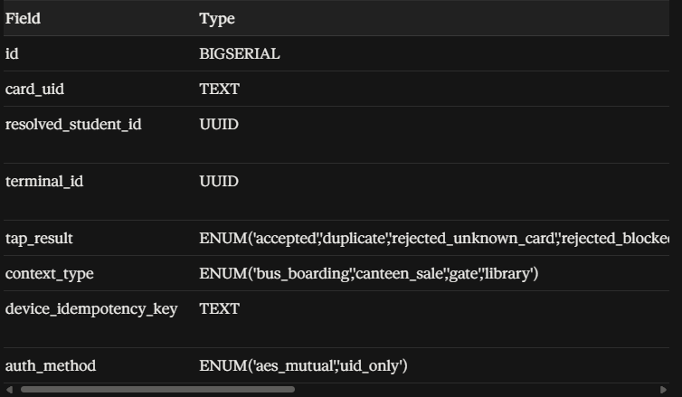

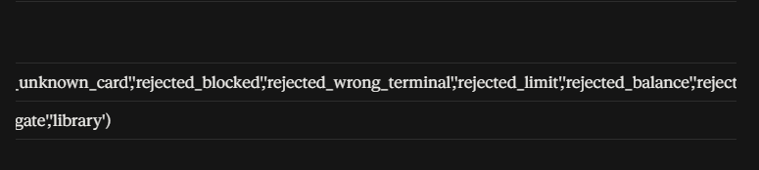

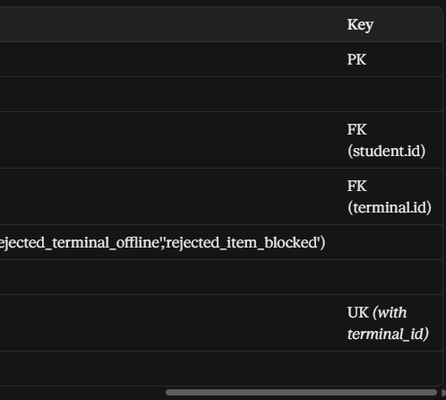

bus_boarding_event

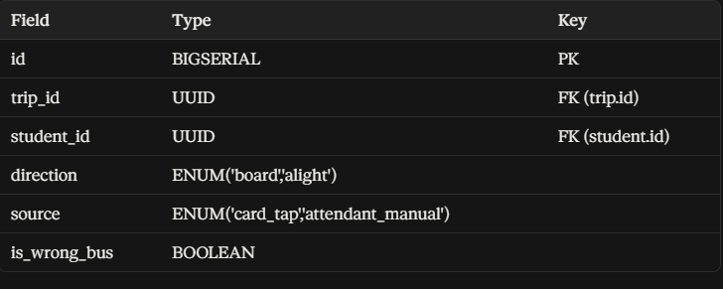

MODULE 11 — Communication & Safety

sos_incident

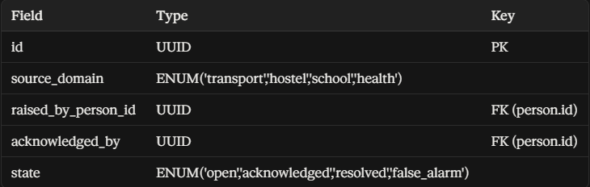

Complaint

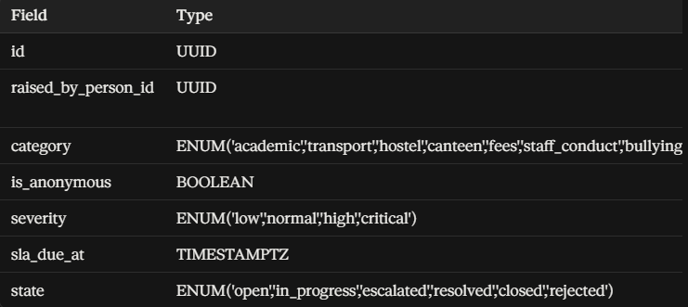

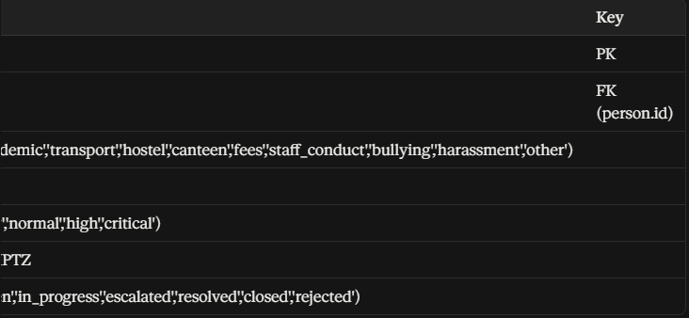

MODULE 12 — Health

medication_schedule

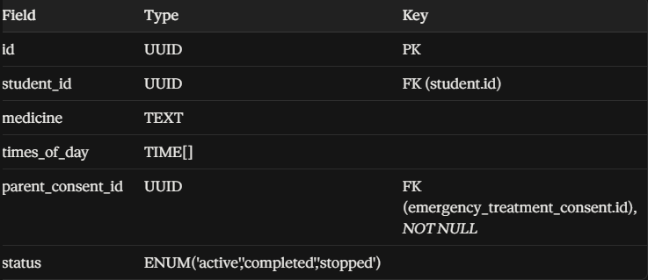

MODULE 13 — Camps

camp_checkup_record

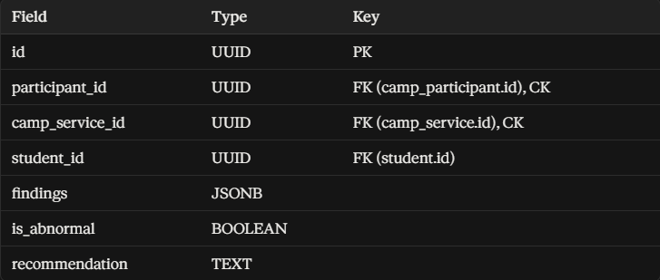

ACID Enforcement Notes

Atomicity

payment + payment_allocation + fee_demand must be written in a single transaction — a payment is never allowed to commit without its matching fee demands being updated, and vice versa. This is exactly how "one payment can cover multiple children" stays safe: either every allocation and every demand update happens together, or none of it does.

pos_transaction + wallet_ledger_entry insert must be transactional, so a canteen sale never exists without its matching wallet debit, and a wallet debit never exists without a matching sale. This directly implements "the sale and the wallet deduction have to happen together, as one action."

mark verification (Academic Coordinator) must check verified_by inside the same transaction that sets state = 'verified', enforcing the same principle used for payroll — a mark can't be marked verified without recording who verified it, checked at the database level, not just in the app.

Consistency

All FK constraints as listed enforce referential integrity — for example, a payment_allocation cannot reference a non-existent fee_demand.id.

CHECK constraints: amount_paise > 0 on payment, paid_paise <= amount_paise + late_fee_paise on fee_demand, end_date >= start_date on academic_year and medication_schedule.

Constraint-based state pairing on payment (confirmed_at required if and only if state is confirmed/reconciled), sos_incident (outcome_note required if and only if state is resolved/false_alarm), and gate_pass (emergency_reason required if and only if is_emergency is true) — so a record can never claim one thing in its state field while another field silently disagrees.

Isolation

Balance-affecting operations (wallet_ledger_entry, hostel_bed allocation) use row-level locking (SELECT ... FOR UPDATE) on the current balance/bed row during a sale or an allocation, to prevent two concurrent requests from double-spending the same wallet balance or assigning two students to the same bed.

Recommended isolation level: READ COMMITTED for general use, escalated to SERIALIZABLE specifically around wallet-debit and bed-allocation transactions — the two places where two people racing to do the same thing at the same moment would actually cause real harm.

Durability

Use Supabase's underlying PostgreSQL with write-ahead logging enabled, and point-in-time recovery/backups turned on, since payment, wallet, and attendance data are all financially or safety-sensitive and must survive a crash mid-transaction without loss.

Table Count Summary

186 tables across 15 modules: Organization & Identity (2), People (3), Academics (17), Assessment (13), Approvals (3), Finance (15), Wallet & Canteen (14), Sports (14), Hostel (14), Transport (18), Cards (5), Communication (11), Health (14), Camps (9), Control Plane & Schema Housekeeping (remainder).

School EOS — Complete Feature Listing, Every Login

1. ADMIN (Web only)

Student Records

Create, edit, and archive student records; manage admission numbers, community category, medium

View complete student profile: academic history, attendance history, health flags, hostel/transport allocation

Admissions

Enquiry pipeline tracking (enquiry → application → review → approval → conversion to student)

Application document upload and verification

Convert an approved application directly into a student record

Staff Records & Role Assignment

Create staff accounts; manage designation, employee number, teaching category

Assign or revoke Faculty assignments (Class Advisor, Academic Coordinator, Health In-Charge, Sports In-Charge, stage In-Charge, Community In-Charge) — same mechanism every time

Mark staff exit (resignation, retirement, transfer, termination)

Transport Setup (fully absorbed from the removed Transport Manager role)

Vehicle records: registration, model, capacity, ownership, maintenance log, document expiry tracking (insurance, permit, fitness certificate)

Route and stop creation, sequencing

Driver and attendant records, license/verification expiry

Student-to-route-and-stop allocation

Vehicle-to-route assignment

GPS device registration and mapping to a vehicle

Live fleet map (oversight)

Transport incident review

Hostel Structure Setup (Admin owns structure; Warden owns daily ops)

Block, floor, room, bed creation

Bed allocation and reassignment per student, per academic year

Hostel-level configuration (capacity, gender, assigned Warden)

Sports Infrastructure (Admin owns infrastructure; Sports In-Charge owns operations)

Sport and category definition

Facility definition (courts, grounds)

Equipment master inventory (add/edit equipment types and stock)

Coach registration, including police-verification expiry tracking

Sports certificate generation

Finance Oversight

Fee structure setup (per grade, per medium, per academic year)

Fee head configuration (tuition, transport, hostel, etc.)

Review and approve refund/concession requests above a set threshold

Device Management

Register every physical device: biometric terminals, GPS trackers, bus terminals, canteen terminals

Monitor device status (online/offline, last-seen, blocklist sync)

Certificates

Generate transfer certificates, bonafide certificates, conduct certificates (templated)

Audit & Compliance

View school-wide audit log (who did what, when)

Upload and version policy documents (SOPs), track staff acknowledgement

Staff Attendance Oversight

View all staff biometric/manual attendance records

Directly mark a staff member's attendance when the biometric terminal is down (counts immediately, no approval needed)

Approve or reject a Faculty member's self-reported manual attendance

2. PRINCIPAL (Web + Mobile — identical logic on both)

Dashboard

Web: full drill-down tables — class/section-wise attendance and performance, teacher performance analytics, public exam benchmarks

Mobile: lighter tile-only summary for quick glance

Approvals

Single inbox: fee concessions, refunds, hostel outings, staff manual attendance, mark corrections — every request type, sorted by urgency

Approve/reject with optional comment

Academic Oversight

Attendance and performance trends by class/section

Teacher performance: syllabus coverage pace, marks-entry timeliness

Report Cards

Final bulk review and sign-off before report cards reach parents (web: many at once; mobile: individual review)

Audit Review

Read-only view of Admin's financial and administrative actions

Announcements

Compose and publish, audience-targeted (whole school / class / individual)

Emergency / SOS

Fire a school-wide alert — requires re-authentication first

Tiered escalation happens automatically server-side (staff first, parents after a delay if unacknowledged)

Live Bus Map

Every active trip, current position, tap for route/boarding status (oversight only, no edit actions)

Quick Lookup

Single search bar across students and staff, read-only summary card

Policy Documents

Create, version, publish; track acknowledgement

Superset of Vice Principal

Everything Vice Principal can do is also available to Principal, by design — enforced at the database level, not just by convention

3. VICE PRINCIPAL (Web only)

Delegated academic oversight (a defined subset of Principal's oversight)

Approve a limited set of requests, as configured by the school

Cannot exceed what Principal holds — this relationship is fixed, not independently maintained

4. FINANCE / ACCOUNTS (Web only)

Fee Management

Set up fee structures and fee heads

Generate fee demands per student, per instalment

Payments

Record payments (cash, UPI, card, cheque, DD)

Every online payment confirmed directly against the bank's own webhook — never trusted from a client screen alone

One payment can cover multiple children at once, with a separate receipt generated per child automatically

Refunds & Concessions

Process refunds/concessions — above a set value, requires Principal approval; Finance can never approve its own request

Payroll

Calculate and process staff salary based on attendance and recorded overtime

Generate payslips

Wallet Reconciliation

Review canteen and transport wallet ledger activity for discrepancies

5. FACULTY (Mobile only — no web version for any assignment)

Core Faculty (every teacher, regardless of assignment)

View own timetable

Mark attendance for own assigned classes/periods

Post homework, learning material, assignments for own subjects

Enter exam marks for own subjects only

View own attendance record (auto-marked via face recognition at the gate)

Self-report own attendance if the biometric terminal is down — goes in as PENDING, requires Admin/Principal confirmation; a teacher can never confirm their own attendance

Apply for leave, check leave balance and status

Post class announcements; message a parent (always logged, never private)

File and track a complaint

+ Class Advisor (extra assignment, same login)

Full attendance and marks view across every subject for one assigned section (not just own subject)

Approve short leave requests for students in that section

Write remarks on report cards

+ Academic Coordinator (extra assignment, same login, mobile-native redesign)

Build timetable — sequential period-by-period entry, not a grid

Assign substitute teachers when staff are absent (time-critical, hallway-speed workflow)

Set up exams — subject-by-subject, with "copy from last term" shortcut

Open/close marks-entry window

Verify marks — anomaly flagging, approve or return with comment

Generate report cards (async job, push notification when ready)

Monitor syllabus coverage across subjects/sections (read-only)

Manage subject-group allotment (Class 11–12 streams)

Review board exam nominal roll (Class 10/12)

+ Sports In-Charge (extra assignment, same login)

Run trials, record results

Build teams and rosters; assign an already-registered coach to a team

Schedule and mark training attendance

Create tournaments and fixtures; enter live match results

Track achievements, feeding the shared student development profile

Issue/return equipment (from Admin-defined stock)

Book facilities for practice/matches

View composed student sport profile (roster + achievements + trial history)

Take PT period attendance — via the same standard attendance mechanism as any subject, since PT is treated as an ordinary class period

+ Health In-Charge (extra assignment, same login)

Record infirmary visits

Administer standing daily medication (only with recorded parent consent)

Manage sick bay admission/discharge

Conduct camp health checkups

Height/weight/BMI visible only to health staff and that child's own parent — never shown elsewhere

+ Class Advisor / Stage In-Charge / Community In-Charge (remaining assignment types)

Stage In-Charge (Primary/Middle/Senior): monitoring across an entire academic stage, not just one section

Community In-Charge: moderate community posts, manage community membership and activities

6. PARENT (Mobile only — shared with Student, no separate student login)

View own children's attendance, marks, homework, fee status, wallet balance

Switch between multiple children if more than one is enrolled

Pay fees online; automatic receipt generation

Top up canteen wallet; set daily spending limit; block specific food items

View live bus location — only while a trip is actively in progress

Message a teacher (logged); receive announcements

File and track a complaint

Request a fee payment extension

View report cards

If the school permits, an older student uses this exact same login — no separate account exists

7. HOSTEL WARDEN (Mobile only, scoped to their own specific hostel)

Night roll call (roster + present/absent)

Issue and approve outing gate passes

Issue an emergency exit immediately (no approval delay) — automatically creates a retrospective review for Principal; the pass cannot close until that review completes

Log visitor entries and exits

Track mess attendance

View (read-only) room/bed allocation for their hostel — cannot create rooms or move students between beds; that stays with Admin, enforced server-side

8. BUS ATTENDANT (Mobile, device-credential login — not a personal login)

Scan a student's card as they board or alight

Sees only name, photo, and assigned stop — nothing else about the child

Wrong-bus boarding is flagged immediately and alerts the office in real time

Closing boarding at end of route automatically flags any unresolved "expected but not boarded" student, unless covered by an approved leave record

9. CANTEEN VENDOR (Mobile/tablet, device-credential login — not a personal login)

Scan a card at the counter; amount deducted from the student's prepaid wallet

Sees name, photo, class, and balance-sufficiency only — never the actual balance figure

Sale automatically blocked at the counter if it would break a parent-set spending limit or hits a blocked item

Supports offline sale queuing if the terminal loses connectivity, synced later with duplicate-safe idempotency

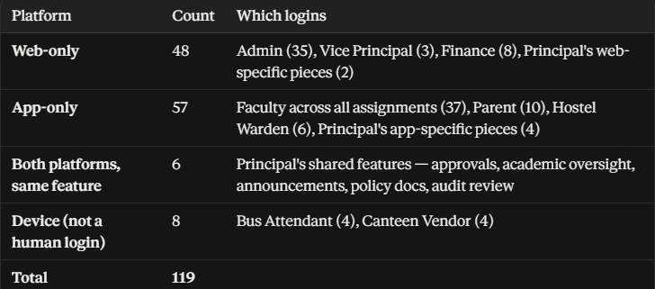

Phase 1 — Authentication, Identity & Session (16 functions)

Authenticate a user and establish an authenticated session · Refresh an access session/token · Terminate the current session · Return the authenticated identity, roles, and assignments · Return current session status · List sessions belonging to the authenticated user · Revoke one owned session · Revoke all sessions · Start password reset (parent policy checked server-side) · Complete an eligible password reset · Verify MFA challenge · Disable MFA after required verification · Admin-authorized parent credential reset/recreation · Liveness check · Readiness check

Phase 2 — School Academic Configuration & People (31 functions)

Academic year: List, Create, Get, Update, Activate, Close · Stage: List, Create, Get, Update · Grade: List, Create, Get, Update · Section: List, Create, Get, Update · Subject: List, Create, Get, Update · Calendar: List, Create, Get, Update · Calendar event: List, Create · Person record: Get, Create, Update

Phase 2 — User Accounts, Roles & Access (26 functions)

Calendar event: Get, Update · Product account: List, Create mapping, Get metadata, Update metadata, Activate, Deactivate · Role: List, Create, Get, Update · Permission: List, Create, Get · Role-permission: List, Assign · Role assignment: List, Assign to account, Update, End · Responsibility assignment: List, Create, Get, Update, End

Phase 2 — Students, Guardians & Enrolment (33 functions)

Student: List/search, Create (outside admission flow), Get, Update, Activate, Deactivate, Archive · Staff: List/search, Create, Get, Update, Activate, Deactivate · Guardian: List, Create, Get, Update · Student-guardian relationship: List, Create, Get, Update, End (without deleting history) · Enrolment: List, Create, Get, Update, Activate, End · Identifier: List, Create, Get, Update, Revoke (preserving history)

Phase 2 — Admissions (9 functions)

List/search admissions · Create admission application (may provision parent account) · Get admission · Update editable data · Submit · Approve · Reject · Withdraw · Create/activate student+enrolment from an approved admission

Phase 3 — Classes, Teaching Assignments & Timetable (28 functions)

Class: List, Create, Get, Update, Activate, Close · Class-subject: List, Attach, Update config, End · Teaching assignment: List, Create, Get, Update, End · Timetable: List, Create, Get, Update · Timetable entry: List, Create, Update, Publish, Lock · Student academic progress: List, Create, Get, Update

Phase 3 — Attendance (14 functions)

Session: List, Create, Get · Record: List, Record, Get · Create controlled correction · Lock session · Unlock under elevated policy · Sync queued offline sessions/records · Record staff biometric check-in/check-out · Record manual staff attendance (terminal down) · List staff attendance events (filterable) · Get one staff attendance event

Phase 3 — Homework, Assignments, LMS & Syllabus (27 functions)

Homework: List, Create, Get, Update, Publish, Close · Assignment: List, Create, Get, Update · Submission: List, Create, Get, Update · Material: List, Create, Get, Update, Publish, Archive · Syllabus: List, Create, Get, Update · Syllabus progress: Get, Record, Correct/update under policy

Phase 3 — Assessment, Examination & Report Cards (38 functions)

Assessment type: List, Create, Get, Update · Assessment: List, Create, Get, Update · Assessment subject: List, Add · Question: Create/configure · Mark: List, Record, Get, Update, Correct (with traceability) · Lock assessment · Publish outcome · Examination: List, Create, Get, Update · Examination schedule: List, Create, Update, Publish · Lock examination config · Grade scale: List, Create, Get, Update · Report card: List, Generate/create, Get, Add/update item, Update item, Publish, Lock

Phase 4 — Student Development & Activities (45 functions)

Activity: List, Create, Get, Update · Offering: List, Create, Update · Participation: List, Create, Update · Activity attendance: List, Record · Achievement: List, Create, Get, Update · Certificate: List, Create, Get · Behaviour record: List, Create, Get, Update (preserving history) · Observation: List, Create, Get, Update (before lock) · Development progress: List, Create, Get, Update · Community: List, Create, Get, Update · In-charge assignment: List, Assign · Profile: List, Create, Get, Update · Participation (secondary set): List, Create, Get, Update

Phase 4 — Community (13 functions)

Membership: List, Create, Update, End · Community activity: List, Create, Update · Participant: List, Add · Attendance: List, Record · Achievement: List, Create

Phase 4 — Sports (61 functions)

Sport: List, Create, Get, Update · Category: List, Create, Update · Offering: List, Create · Trial: List, Create, Get, Update · Result: List, Record · Team: List, Create, Get, Update · Roster: List, Add member, End membership · Coach: List, Assign · Training session: Create, List, Update · Training attendance: List, Record · Tournament: List, Create, Get, Update · Tournament entry: List, Create · Fixture: List, Create, Get, Update, Record result · Ranking: List, Record/update snapshot · Sports achievement: List, Create · Sports certificate: List, Create · Facility: List, Create, Get, Update · Booking: List, Create, Update, Cancel · Equipment: List, Create, Get, Update · Issue: List, Issue, Record return

Phase 5 — Finance, Fees & Payments (43 functions)

Fee structure: List, Create, Get, Update, Activate, Deactivate (preserving history) · Financial obligation: List, Create, Get · Import job: List, Create, Get status, Validate, Commit, Cancel · Payment: List, Create intent/transaction, Get, Receive/process verified event (provider-facing) · Allocation: List, Allocate to obligations · Receipt: Get metadata, Generate · Refund: List, Create, Get · Expense: List, Create, Get, Update draft, Submit, Approve, Reject, Cancel · Reconciliation: List, Create, Get, Run, Resolve discrepancy, Close · Fee extension: Request, List, Get

Phase 5 — Wallet & Canteen (39 functions)

Wallet: List, Create, Get status/balance, Activate, Freeze, Unfreeze · Wallet limit: List, Create, Update, Deactivate · Wallet transaction: List · Ledger entry: List (authoritative) · Credit (top-up) · Debit (purchase) · Refund/compensation entry: Create · Canteen: List, Create, Get, Update · Product: List, Create, Get, Update, Activate, Deactivate · Canteen transaction: List, Create authoritative sale, Get · Auto-top-up: Create, Get active, Update threshold, Cancel · Menu item: List, Create/update · Meal pre-order: Create+pay, List, Record collection (card tap), Cancel+refund uncollected · Sync queued offline canteen sales

Phase 6 — Transport, NFC, GPS & Devices (67 functions)

Device: List, Register, Get, Update, Activate, Deactivate · Device assignment: List, Assign, Update, End · Device heartbeat · Vehicle: List, Create, Get, Update, Activate, Deactivate · Route: List, Create, Get, Update · Route stop: List, Create, Update, Activate, Deactivate · Transport assignment: List, Assign student, Get, Update, End · Trip: List, Create, Get, Start, Complete, Cancel · NFC card: List, Register, Get status, Update metadata, Assign, Activate, Suspend, Revoke permanently, Get history · Tap event: Ingest single, Sync queued offline · Validated transport event: List, Get · GPS: Ingest telemetry, Read trip telemetry · Transport incident: List, Create, Get, Update, Close · Boarding event: Record board/alight, List for trip · Per-student status board for a trip · List students expected-but-not-boarded · Finalise boarding (auto-flags not-boarded) · Current transport status for one student · Current vehicle position (active trip) · Card personalisation: Issue single-use token, Confirm personalisation · Get current card blocklist (terminal sync)

Phase 7 — Hostel (67 functions)

Hostel: List, Create, Get, Update, Activate, Deactivate · Block: List, Create, Get, Update, Activate, Deactivate · Room: List, Create, Get, Update · Bed: List, Create, Get, Update, Activate, Deactivate · Allocation: List, Create, Get, Check-in, Check-out, Transfer · Attendance session: List, Create, Get · Attendance record: List, Record, Get, Controlled correction, Lock session · Leave request: List, Create, Get, Update, Approve, Reject, Cancel · Hostel incident: List, Create, Get, Update, Close · Infirmary visit: List, Create, Get, Record vitals, Get vitals · Sick bay: Admit, Discharge · Medication order: Record plan, List visit medications, Record administration · Escalation: Create, Get · Hospital referral: Create, Get, Complete · Follow-up: Create, List, Complete · Close visit

Phase 8 — Health / Infirmary (43 functions — this section covers communication/documents in the source doc)

Announcement: List, Create, Get, Update draft, Schedule, Publish, Cancel scheduled, Expire · Notification: List own, Get own, Mark read, Mark all visible read · Preference: Get own, Create set, Update own · Conversation: List, Create, Get · Participant: List, Add · Message: List, Send, Attach file · Document: List, Create upload session, Get metadata, Update metadata, Finalize object · Business-object link: List, Link · Document version: List, Create, Verify, Reject, Archive · Evidence: List, Create, Get, Archive (without destroying audit trail) · Standing medication schedule: Create, List, Stop · Medication doses due within a time window: List

Phase 9 — Incidents, Discipline, Safety & Emergency (30 functions)

General incident: List, Create, Get, Update · Participant: List, Add · Evidence: List, Attach · Close incident · Discipline case: List, Create, Get, Update, Move to investigation · Finding: List, Record · Decision: Record · Disciplinary action: List, Create, Complete · Resolve case · Close case · Safety incident: List, Create, Get, Update · Follow-up: List, Create, Complete · Close safety incident

Phase 9 — Communication, Notifications, Documents & Evidence (10 functions — this section covers Emergency in the source doc)

Emergency: List, Create record, Get, Declare · Response action: Record · Escalation: List, Create · Resolve emergency · Close emergency record · Receive verified delivery status event (provider-facing)

Phase 9a — Complaints (2 functions)

List complaints within scope · File a complaint

Phase 10 — Approvals (5 functions)

List approvals available to caller · Create workflow approval request · Get approval request · Approve current step · Reject current step

Phase 10 — Bulk Operations (8 functions)

List bulk jobs · Create bulk job · Get job status · Attach/import input · Dry-run/validate · Confirm processing · Cancel before irreversible processing · Get structured row-level errors/results

Phase 10 — Audit (3 functions)

Query audit events allowed to caller · Get one audit event · Add controlled annotation

Phase 10 — Reporting & Scheduled Operations (10 functions)

Leadership dashboard (composite: attendance %, fee collection, complaints, approvals, SOS) · Academic oversight dashboard · Finance dashboard · Hostel dashboard · Scheduled export: List, Create, Get, Update, Activate, Deactivate

Phase 11 — Camps (26 functions)

Camp: List, Create, Get, Update, Announce, Mark ongoing, Complete, Cancel · Camp session: List, Create · Camp service: List, Define · Participant: List, Register, Record parent consent · Session attendance: Mark · Checkup record: List, Record finding, Get, Correct (before camp completes) · Follow-up: List, Create, Complete · Camp partner: List, Register · Student's camp participation/findings: List

